"Roadrunner"

Stages Written by: Striker

The roadrunner (genus Geococcyx), also known as a chaparral bird or chaparral cock, is a fast-running ground cuckoo that has a long tail and a crest. It is found in the southwestern United States and Mexico, usually in the desert. Some have been clocked at 20 miles per hour (32 km/h).

The roadrunner generally ranges in size from 22 to 24 in (56 to 61 cm) from tail to beak. The average weight is about 8–15 oz (230–430 g). The roadrunner is a large, slender, black-brown and white-streaked ground bird with a distinctive head crest. It has long legs, strong feet, and an oversized dark bill. The tail is broad with white tips on the three outer tail feathers. The bird has a bare patch of skin behind each eye; this patch is shaded blue anterior to red posterior. The lesser roadrunner is slightly smaller, not as streaky, and has a smaller bill. Both the lesser roadrunner and the greater roadrunner leave behind very distinct "X" track marks appearing as if they are travelling in both directions.

Roadrunners and other members of the cuckoo family have zygodactyl feet. The roadrunner can run at speeds of up to 20 miles per hour (32 km/h) and generally prefer sprinting to flying, though it will fly to escape predators. During flight, the short, rounded wings reveal a white crescent in the primary feathers.

The roadrunner usually lives alone or in pairs. Breeding pairs are monogamous and mate for life, and pairs may hold a territory all year. During the courtship display, the male bows, alternately lifting and dropping his wings and spreading his tail. He parades in front of the female with his head high and his tail and wings drooped, and may bring an offering of food. The reproductive season is spring to mid-summer (depending on geographic location and species).

The roadrunner's nest is often composed of sticks, and may sometimes contain leaves, feathers, snakeskins, or dung. It is commonly placed 1–3 meters above ground level in a low tree, bush, or cactus. Roadrunner eggs are generally white. The greater roadrunner generally lays 2–6 eggs per clutch, but the lesser roadrunner's clutches are typically smaller. Hatching is asynchronous. Both sexes incubate the nest (with males incubating the nest at night) and feed the hatchlings. For the first one to two weeks after the young hatch, one parent remains at the nest. The young leave the nest at two to three weeks old, foraging with parents for a few days after.

The Roadrunner appears as the primary antagonist in Wile E. Coyote and The Road Runner cartoon by the Warner Brothers, as part of the Looney Tunes series. The bird in the programme is based on the Greater roadrunner species of the bird.

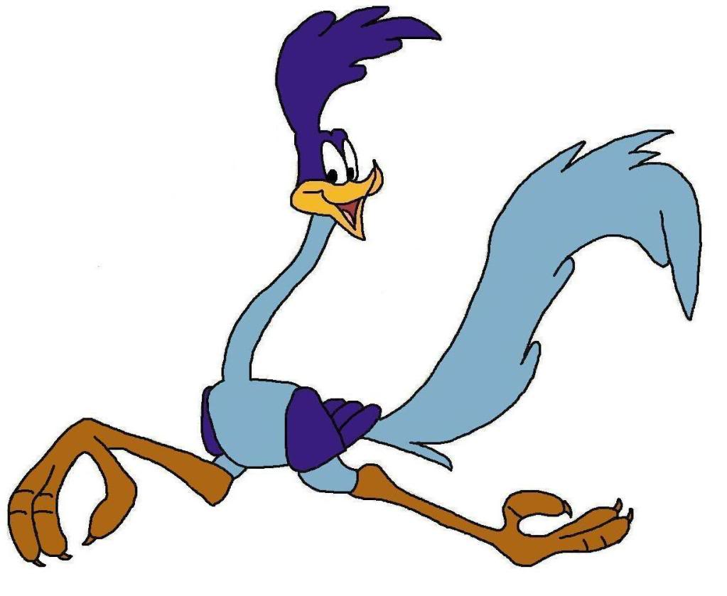
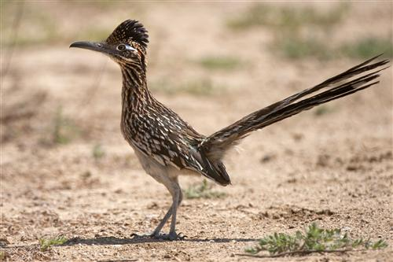

Mattaponi Sundowners – Rules and Stage Conventions
- Revised 04-24-2013 -

- SASS Rules: All SASS Rules are in affect; unless documented here, address during the Shooter Safety Meeting or specifically stated in the stage description for a given stage.

- Round Over Berm: A round fired over the berm is a Match DQ, excluding shotguns.

- “No Alibi”: All matches at Mattaponi are “no alibi” matches. “Once the first round goes down range, the competitor is committed to the stage and must finish the stage to the best of his or her ability. Reshoots/restarts are not awarded for ammunition or firearm malfunctions. However, if there is a range failure (failure of props, timer, or the range officers) beyond the competitor’s control, a restart may be granted. On a reshoot/restart, the competitor starts over clean, carrying only accrued safety penalties forward. Restarts shall be allowed for a competitor to achieve a “clean” start up to the point at which the first round goes down range. Multiple restarts by the same shooter, that in the judgment of the R.O. are seen to be taking advantage, will not be entertained as they are not in the spirit of the game.”

- SASS Stage Conventions: Unless specifically stated in the stage description for a given stage, all SASS Stage Conventions are in affect.

- Shotgun Knockdown Misses: Unless specifically stated in the stage description for a given stage and pursuant to SASS rules, all shotgun knockdown targets may be reengaged until down, aka “Comstock Rule”.

- Loading on the Move: Loading on the move is permitted pursuant to SASS rules.

- Drawing on the Move: Drawing on the move is permitted pursuant to SASS rules.

- Muzzle Position: When there is a risk of a prop blocking the muzzle of a firearm, the muzzle must be positioned downrange of the prop, as determined by the Range Officer. For example: shooting through the window of a store front or shooting beside a wall.

- End of Stage: Unless otherwise directed by a Range Officer, after a stage has been completed the shooter will safely retrieve rifle, shotgun, and pistols and move them to the unloading table. The shooters firearms will not leave the unloading table until they have been verified “cleared” by a Range Officer.

- Coaching: Any shooter who wishes to not receive coaching must state their preference at the beginning of each stage. The Mattaponi Sundowners strongly believe that shooters helping shooters (coaching) is a critical component of the “Cowboy Way” and part of what makes this game great!! Therefore coaching is strongly encouraged and supported.

The Spotters Creed:
If you know that it’s a Hit…It’s a Hit
If you know that it’s a Miss…It’s a Miss
If you think it’s a Hit…It’s a Hit
If you think it’s a Miss…IT’S A HIT

Benefit of the doubt always goes to the shooter
STAGE ONE (Bay #2)

Round Count: 10 pistol, 10 rifle, 5+ shotgun

Shooting Order: Rifle, Shotgun, Shotgun, Pistols

Staging: Rifle is loaded with 10 rounds and staged safely. Shotgun is staged safely.

Procedure: Posture is shooters choice. Shooter starts at Position 2 and when ready says “Beep, Beep”. At the beep with rifle shoot at targets (R1 thru R5) in the following order: (R3, R3, R1, R2, R3, R3, R5, R4, R3, R3). Next with shotgun shoot at the (X1) knockdown. Move to Position 3 and then with shotgun shoot at knockdowns (S1 thru S4). Move to Position 1 and then with pistols shoot at targets (P1 thru P5) using the same instructions as the rifle.

21”
h/l
R3
21”
s
R2
21”
s
R4
21”
h/l
R1
21”
h/l
R5
16”
h
P3
16”
s
P2
16”
s
P4
16”
m
P5
16”
m
P1
X1

S1

S2

S3

S4

Hay Bale
Position 1
Pistols
Hay Bale
Position 2
Rifle & Shotgun
Hay Bale
Position 3
Shotgun

STAGE TWO (Bay #2)

Round Count: 10 pistol, 10 rifle, 2+ shotgun

Shooting Order: Shotgun, Shotgun, Rifle, Pistols

Staging: Rifle is loaded with 10 rounds and staged safely. Shotgun is staged safely.

Procedure: Posture is shooters choice. Shooter starts at Position 3 and when ready says “Beep, Beep”. At the beep with shotgun shoot at any 1 of the knockdown targets (S1 thru S4) then move to Position 2 and then with shotgun shoot at the X1 knockdown target. Next with rifle shoot at targets (R1 thru R5) with 2 shots each. Move to Position 1 and then with pistols shoot at targets (P1 thru P5) using the same instructions as the rifle.

21”
h/l
R3
21”
s
R2
21”
s
R4
21”
h/l
R1
21”
h/l
R5
16”
h
P3
16”
s
P2
16”
s
P4
16”
m
P5
16”
m
P1
X1

S1

S2

S3

S4

Hay Bale
Position 1
Pistols
Hay Bale
Position 2
Rifle & Shotgun
Hay Bale
Position 3
Shotgun

STAGE THREE (Bay #2)

Round Count: 10 pistol, 10 rifle, 4+ shotgun

Shooting Order: Pistols, Rifle, Shotgun

Staging: Rifle is loaded with 10 rounds and staged safely. Shotgun is staged safely.

Procedure: Posture is shooters choice. Shooter starts at Position 1 with hands on pistol(s) and when ready says “Beep, Beep”. At the beep with pistols shoot at the targets (P1 thru P5) in the following order (Middle, Inside, Other Inside, Outside, Other Outside, Middle, Inside, Other Inside, Outside, Other Outside). Move to Position 2 and then with rifle shoot at targets (R1 thru R5) using the same instructions as the pistols. Last move to Position 3 and then with shotgun shoot at knockdowns (S1 thru S4).

21”
h/l
R3
21”
s
R2
21”
s
R4
21”
h/l
R1
21”
h/l
R5
16”
h
P3
16”
s
P2
16”
s
P4
16”
m
P5
16”
m
P1
X1

S1

S2

S3

S4

Hay Bale
Position 1
Pistols
Hay Bale
Position 2
Rifle
Hay Bale
Position 3
Shotgun

STAGE FOUR (Bay #2)

Round Count: 10 pistol, 10 rifle, 4+ shotgun

Shooting Order: Shotgun, Rifle, Pistols

Staging: Rifle is loaded with 10 rounds and staged safely. Shotgun is staged safely.

Procedure: Posture is shooters choice. Shooter starts at Position 3 and when ready says “Beep, Beep”. At the beep with shotgun shoot at knockdowns (S1 thru S4). Move to Position 2 and then with rifle shoot at targets (R1, R3, R5) with triple taps and then shoot at target (X1), the (X1) target may be reengaged with rifle reloads. Move to Position 1 and then with pistols shoot at targets (P1 thru P5) in a West Virginia Sweep, for example (P1, P2, P3, P4, P5, P5, P4, P3, P2, P1).

STAGE FIVE (Bay #3)
21”
h/l
R3
21”
s
R2
21”
s
R4
21”
h/l
R1
21”
h/l
R5
16”
h
P3
16”
s
P2
16”
s
P4
16”
m
P5
16”
m
P1
X1

S1

S2

S3

S4

Hay Bale
Position 1
Pistols
Hay Bale
Position 2
Rifle
Hay Bale
Position 3
Shotgun

Round Count: 10 pistol, 10 rifle, 4+ shotgun

Shooting Order: Rifle, Pistols, Shotgun

Staging: Rifle is loaded with 10 rounds and pointed down range. Shotgun is staged safely.

Procedure: Posture is shooters choice. Shooter starts at Position 2 with the rifle pointed down range and when ready says “Beep, Beep”. At the beep with rifle shoot at targets (R1 thru R5) in the following order (R1, R3, R3, R2, R3, R3, R4, R3, R3, R5). Move to Position 1 and then with pistols shoot at targets (P1 thru P5) using the same instructions as the rifle. Move to Position 3 and then with shotgun shoot at knockdowns (S1 thru S4).

21”
h/l
R3
21”
s
R2
21”
s
R4
21”
h/l
R1
21”
h/l
R5
16”
h
P3
16”
s
P2
16”
s
P4
16”
m
P5
16”
m
P1
X1

S1

S2

S3

S4

Hay Bale
Position 1
Pistols
Hay Bale
Position 2
Rifle
Hay Bale
Position 3
Shotgun

STAGE SIX (Bay #3)

Round Count: 10 pistol, 10 rifle, 4+ shotgun

Shooting Order: Pistols, Rifle, Shotgun

Staging: Rifle is loaded with 10 rounds and staged safely. Shotgun is staged safely.

Procedure: Posture is shooters choice. Shooter starts at Position 1 with hands above shoulders and when ready says “Beep, Beep”. At the beep with pistols shoot at targets (P1 thru P5) in the following order (P3, P2, P2, P5, P5, P4, P4, P1, P1, P3). Move to Positions 2 and then with rifle shoot at targets (R1 thru R5) using the same instructions as the pistols. Move to Position 3 and then with shotgun shoot at knockdowns (S1, thru S4).

21”
h/l
R3
21”
s
R2
21”
s
R4
21”
h/l
R1
21”
h/l
R5
16”
h
P3
16”
s
P2
16”
s
P4
16”
m
P5
16”
m
P1
X1

S1

S2

S3

S4

Hay Bale
Position 1
Pistols
Hay Bale
Position 2
Rifle
Hay Bale
Position 3
Shotgun

