SASS Presents:
Smoke on the Mattaponi IX
The Virginia State Blackpowder Shootout
June 25th, 2016

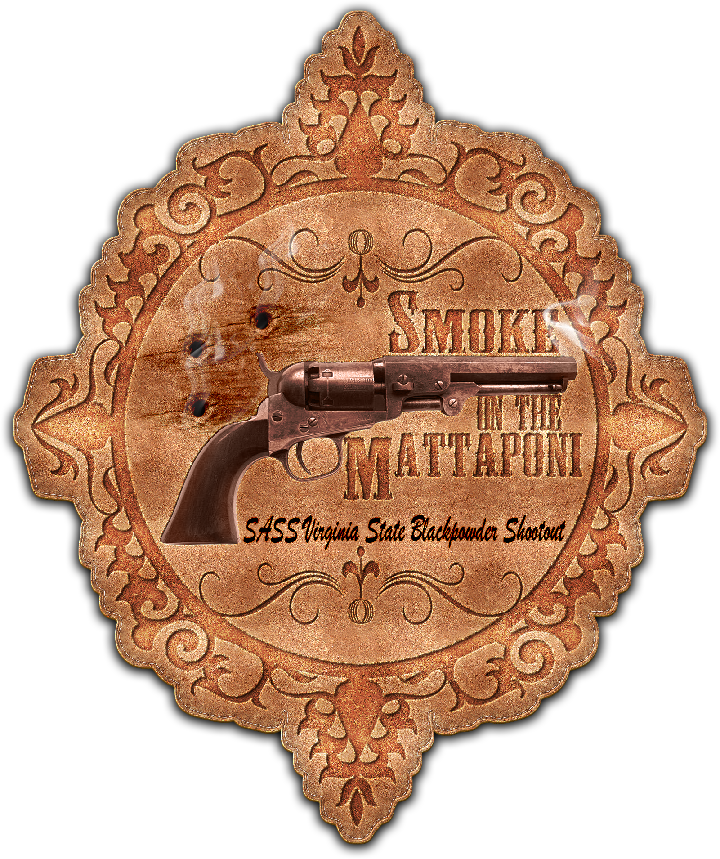

Hosted By
The West Point Gun Club &
The Mattaponi Sundowners

Main Match Sponsor
Reb’s Bullets

( Inside Front Cover – This page is blank )
Welcome Cowboys & Cowgirls,

On behalf of the West Point Gun Club and the Mattaponi Sundowners I would like to welcome everyone to Smoke on the Mattaponi IX, the sixth SASS Virginia State Black Powder Shootout. I would like to thank Sassy Shooting Sours (aka Pat Graves), and Potter County Kid (aka Gary Graves) for their help with this match. I would like to recognize and sincerely thank all of our Smoke on the Mattaponi Sponsors!!, they make this match possible. We can all thank them by supporting their businesses. May everyone here today have fun, shoot straight, be safe, and come back again.

Les Lillge, aka Striker
Match Director
President, West Point Gun Club

WWW.WESTPOINTGUNCLUB.COM
Match Officials

Striker
Match Director
WPGC President

Sassy Shooting Sours
Assistant Match Director
Sponsorship Czar

Potter County Kid
Assistant Match Director
WPGC Range Director

Missouri Marshal
TG Mattaponi Sundowners

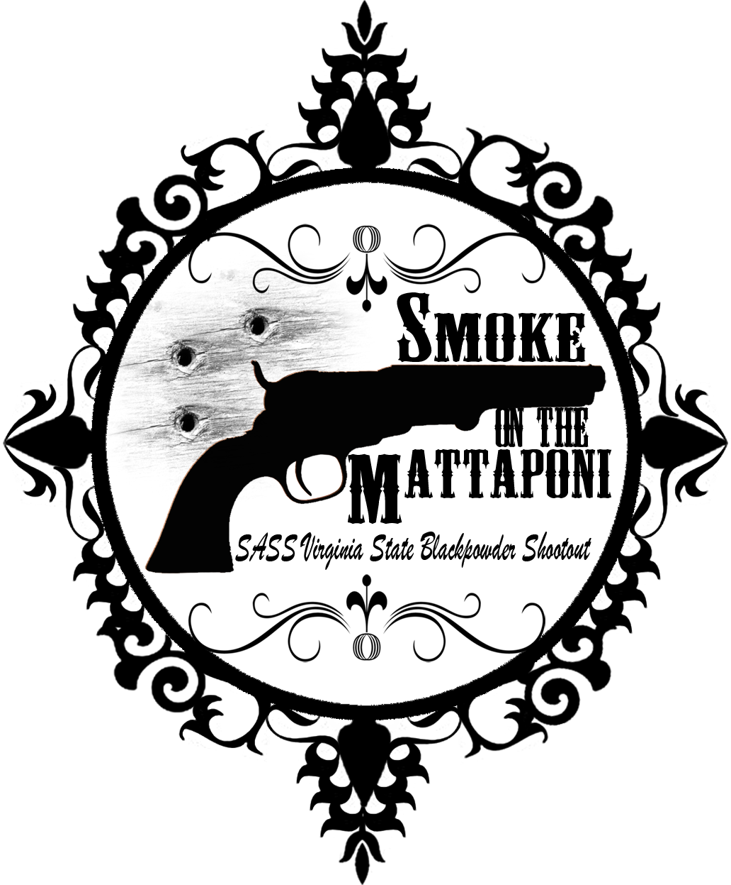
Mattaponi Sundowners – Rules and Stage Conventions
- Revised 04-24-2013 -

- SASS Rules: All SASS Rules are in affect; unless documented here, address during the Shooter Safety Meeting or specifically stated in the stage description for a given stage.

- Round Over Berm: A round fired over the berm is a Match DQ, excluding shotguns.

- “No Alibi”: All matches at Mattaponi are “no alibi” matches. “Once the first round goes down range, the competitor is committed to the stage and must finish the stage to the best of his or her ability. Reshoots/restarts are not awarded for ammunition or firearm malfunctions. However, if there is a range failure (failure of props, timer, or the range officers) beyond the competitor’s control, a restart may be granted. On a reshoot/restart, the competitor starts over clean, carrying only accrued safety penalties forward. Restarts shall be allowed for a competitor to achieve a “clean” start up to the point at which the first round goes down range. Multiple restarts by the same shooter, that in the judgment of the R.O. are seen to be taking advantage, will not be entertained as they are not in the spirit of the game.”

- SASS Stage Conventions: Unless specifically stated in the stage description for a given stage, all SASS Stage Conventions are in affect.

- Shotgun Knockdown Misses: Unless specifically stated in the stage description for a given stage and pursuant to SASS rules, all shotgun knockdown targets may be reengaged until down, aka “Comstock Rule”.

- Loading on the Move: Loading on the move is permitted pursuant to SASS rules.

- Drawing on the Move: Drawing on the move is permitted pursuant to SASS rules.

- Muzzle Position: When there is a risk of a prop blocking the muzzle of a firearm, the muzzle must be positioned downrange of the prop, as determined by the Range Officer. For example: shooting through the window of a store front or shooting beside a wall.

- End of Stage: Unless otherwise directed by a Range Officer, after a stage has been completed the shooter will safely retrieve rifle, shotgun, and pistols and move them to the unloading table. The shooters firearms will not leave the unloading table until they have been verified “cleared” by a Range Officer.

- Coaching: Any shooter who wishes to not receive coaching must state their preference at the beginning of each stage. The Mattaponi Sundowners strongly believe that shooters helping shooters (coaching) is a critical component of the “Cowboy Way” and part of what makes this game great!! Therefore coaching is strongly encouraged and supported.

The Spotters Creed:
If you know that it’s a Hit…It’s a Hit
If you know that it’s a Miss…It’s a Miss
If you think it’s a Hit…It’s a Hit
If you think it’s a Miss…IT’S A HIT

Benefit of the doubt always goes to the shooter
SASS Sanctioned Black Powder Shootout

This match has been sanctioned by SASS as "The SASS Virginia State Black Powder Shootout". It will be operated according to SASS Rules and the sanctioning agreement between SASS and the West Point Gun Club.
In order to differentiate the black powder match from the standard state level match, SASS requires us to refer to the state black powder match as the "Virginia State Black Powder Shootout". Whereas the standard state level match is referred to as the "Virginia State Championship".
SASS requires us to only recognize Category Winners and not to recognize nor award any Overall Shooters for the match.
SASS is awarding the official SASS Black Powder Shootout Winner Pin to every Category Winner.
The following are rules specific to the Black Powder Shootout:
- All ammunition must be black powder or an approved substitute
- Scored as a Total Time Match
- Category Winners may be from any state
- All Shooters must be a current SASS member
- Category Awards Only, No Overall Awards will be Presented

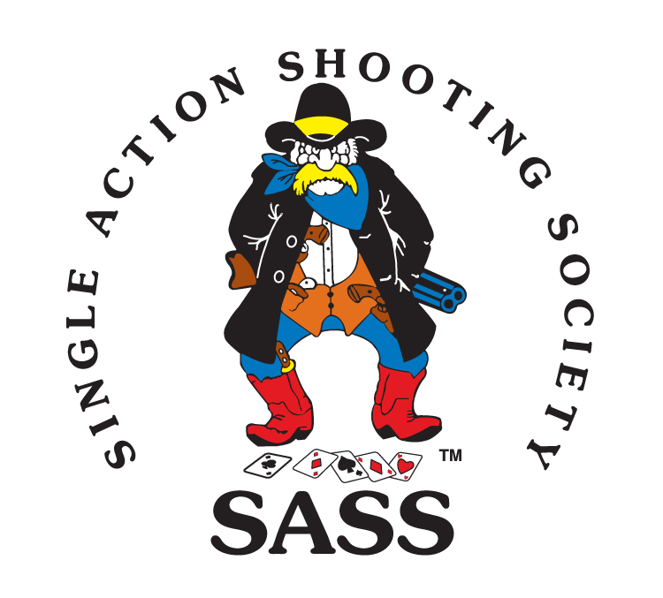

The West Point Gun Club and the Mattaponi Sundowners would like thank all of our sponsors, without their generosity and support this match would not be possible, Thank You!! We call on all of our cowboy friends to support our sponsors.

Main Match Sponsor
Reb’s Bullets – Reb Roberts

Presenting Sponsors
American Pioneer Powder, Inc.
DeGoff’s Inc.
Liberty Safes of Richmond
Nick’s Spaghetti & Steak House
One Eyed Rooster

Stage Sponsors
Colonial Firearms
Manakin Masonry – Major BS Walker
Missouri Marshal’s Loading Blocks
Old Hickory Gun Club
Sassy Shooting Sours & Potter County Kid
Six Rivers Armory
Sodan Armament
Trapper Dan Trading
Wistful McClintock & Inita Shoot

Door Prize Sponsors
Duke’s Smith & Arms - Hotshod & Filthy Five
FireArms Sales Company
Hopkins Gun and Tackle
RedNex Sporting Goods

Main Match Sponsor
Reb’s Bullets
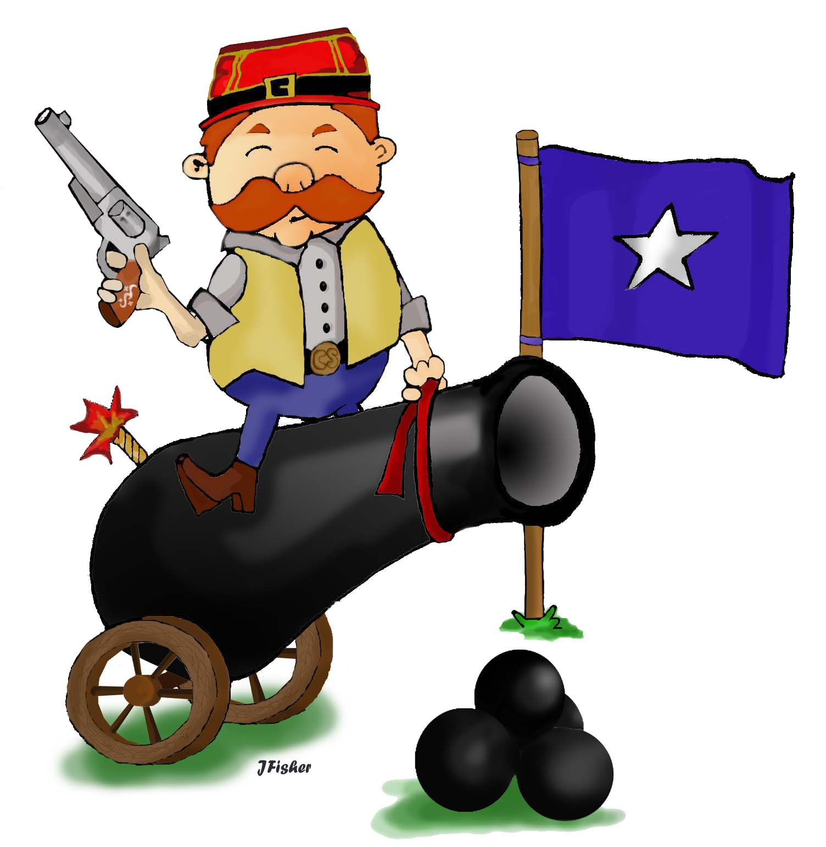

Will Roberts aka “Reb Roberts”
1124 Bethel Prospect Rd
Prospect TN 38477
757.358.1082
long_range45@hotmail.com

Reb’s Bullets

Spring/Summer 2016 Pricing:

SASS® Compliant, all lead construction. Our alloy is guaranteed to be BHN 10 or harder.

All bullets are lubed with a hard lubricant. Unlubed bullets available on special order basis.

Caliber | Type | Weight (grains) | Cost/Quantity
.38 (.358) | Truncated Cone, Flat Point, Bevel Base | 105 | $30/500
.38 (.358) | Truncated Cone, Flat Point, Bevel Base | 125 | $33/500
.38 (.358) | Round Nose, Flat Point, Bevel Base | 158 | $35/500
.45 (.452) | Round Nose, Flat Point | 180 | $40/500
.45/70 (.459) | Round Nose, Flat Point | 300 | $17/100
.45/70 (.459) | Round Nose, Flat Point | 405 | $19/100

We ship in lots of 3 or 4 boxes of 500 for free.

Contact:

Will Roberts (a.k.a. Reb)

Long_range45@hotmail.com

Snail mail to:

Will Roberts
1124 Bethel Prospect Rd.
Prospect TN 38477

Presenting Sponsors

American Pioneer Powder, Inc.

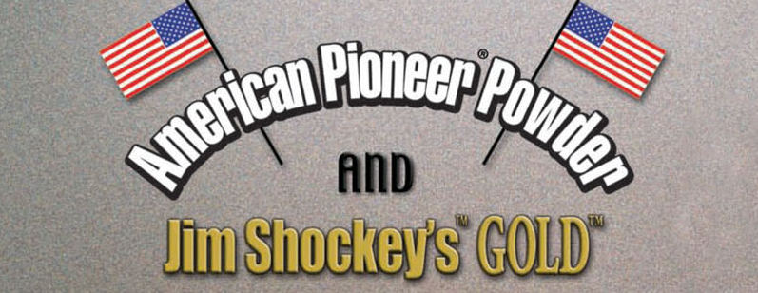

www.americanpioneerpowder.com

DeGoff’s, Inc.

www.degoffsva.com
Presenting Sponsors

Liberty Safe of Richmond

www.libertysafe.com

Nick’s Spaghetti & Steak House

www.nicksspaghettiandsteak.com

Presenting Sponsors

One Eyed Rooster

oneeyedrooster1942@yahoo.com

Stage Sponsors

Robert Wilson

Major B.S. Walker
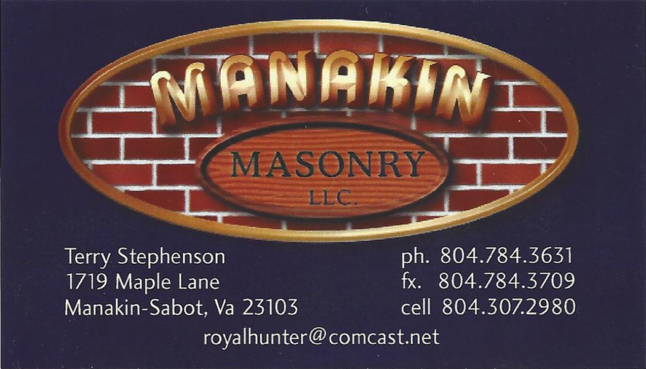

www.MissouriMarshal.net
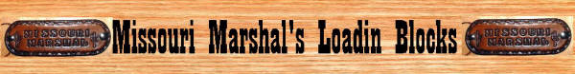

Stage Sponsors

Old Hickory Gun Club
www.oldhickorygunclub.com

Sassy Shooting Sours &
Potter County Kid

Six Rivers Armory

Stage Sponsors

www.SodanArms.com
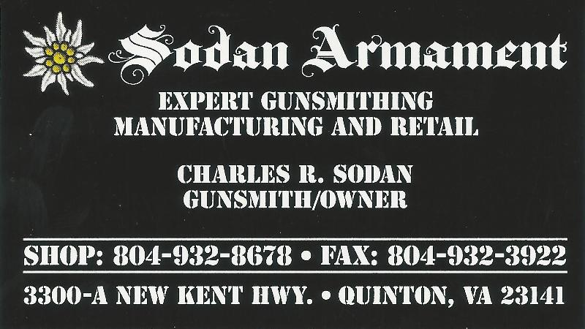

Trapper Dan Trading
trapperdanllc@verizon.net

Wistful McClintock &
Inita Shoot

Door Prize Sponsors

Duke’s Smith & Arms
Hotshod & Filthy Five - opsrmd@aol.com

FireArms Sales Company
www.firearmsalescompany.com

Hopkins Gun and Tackle
www.hopkinshuntfish.com

RedNex Sporting Goods
www.rednex-sports.com

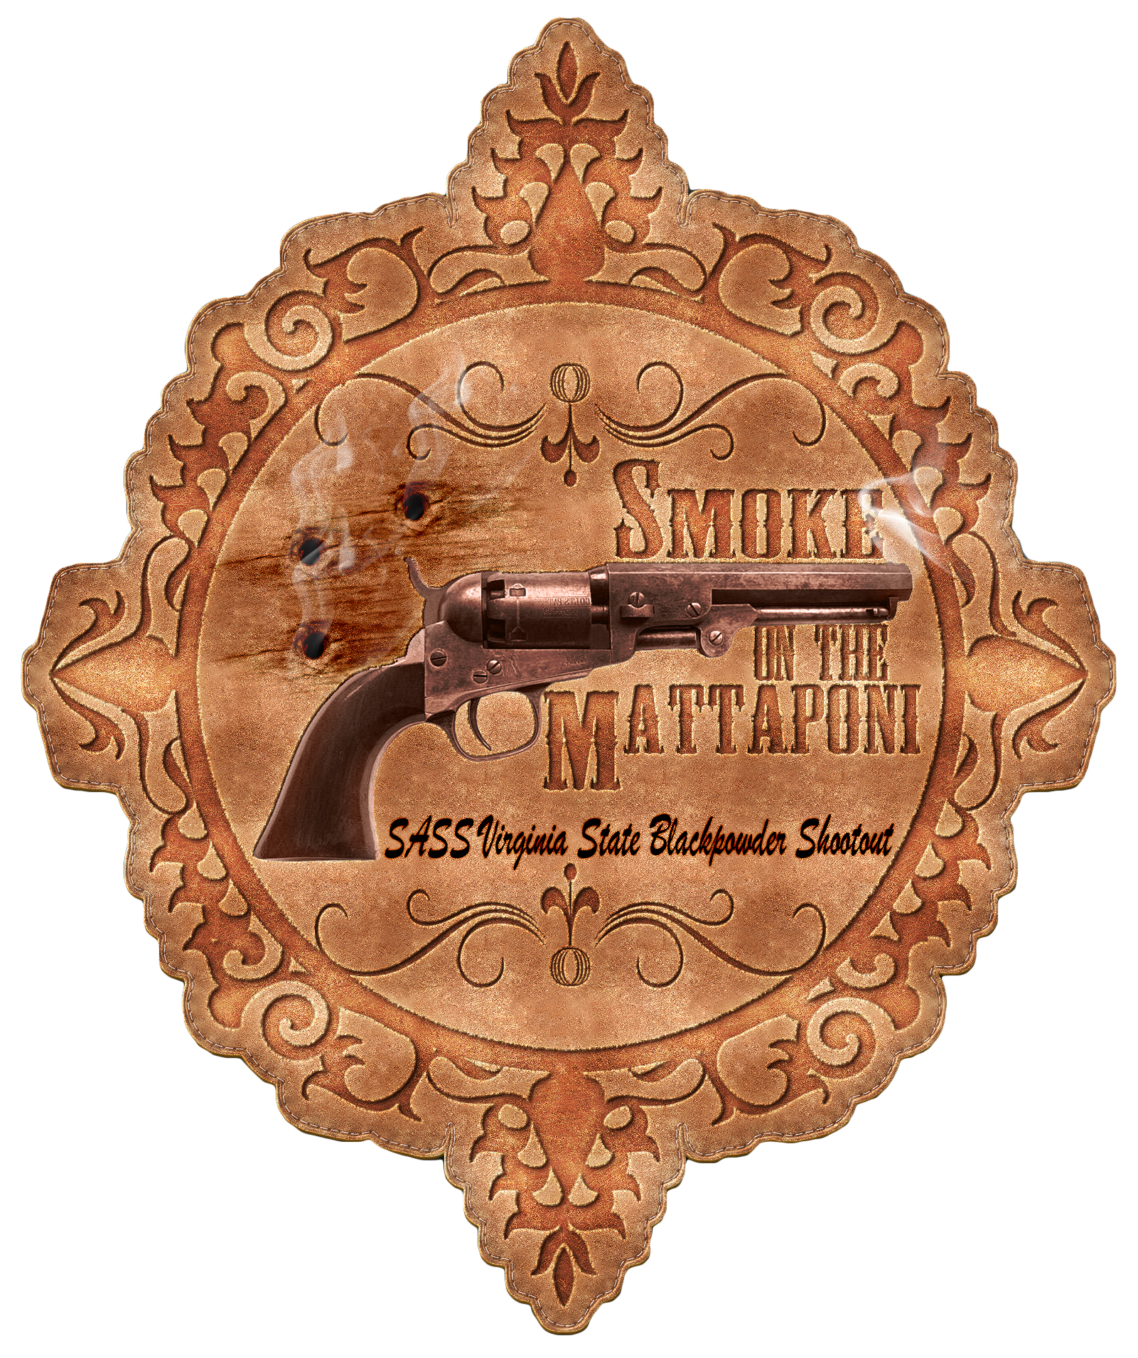

STAGE ONE (Bay #1) – “Gunfight on the Beonthenoon Stage Coach”

Sponsored By: Colonial Firearms – Robert Wilson

Story: John Henry Quick has been riding on the Beonthenoon Stage Coach for six long hours when the driver decides to stop beside the Mattaponi River to water the horses. Climbing down from the coach, John Henry lights up his favorite ten cent cigar and begins walking along the river to stretch his legs. As he is walking, he hears a voice from behind some trees, “My name is Bad Rock and I will be taking all of your gold and silver”. John Henry Quick bites down on his cigar, grabs both of his six shooters and says to Bad Rock, “All I have is lead!!”.

Round Count: 10 pistol, 10 rifle, 4+ shotgun

Shooting Order: Shotgun, Rifle, Pistols or Rifle, Pistols, Shotgun

Staging: Rifle is loaded with 10 rounds and staged safely. Both pistols are loaded with 5 rounds each and holstered. Shotgun is staged safely.

Procedure: Shooter has the choice of starting at Position 2 or Position 3. Shooter starts with hands above shoulders and when ready says “All I have is lead!!”. At the beep: From Position 2 with shotgun engage the four knockdown targets (S1, S2, S3, S4) in any order. From Position 3 with rifle engage the four rifle targets (T1, T2, T3, T4) with double taps on the end targets, single taps on the inside targets, all targets engaged for ten rounds. Next with pistols engage the four pistol targets (P1, P2, P3, P4) using the same instructions as the rifle.

Notes:

STAGE ONE (Bay #1) – “Gunfight on the Beonthenoon Stage Coach”

Sponsored By: Colonial Firearms – Robert Wilson

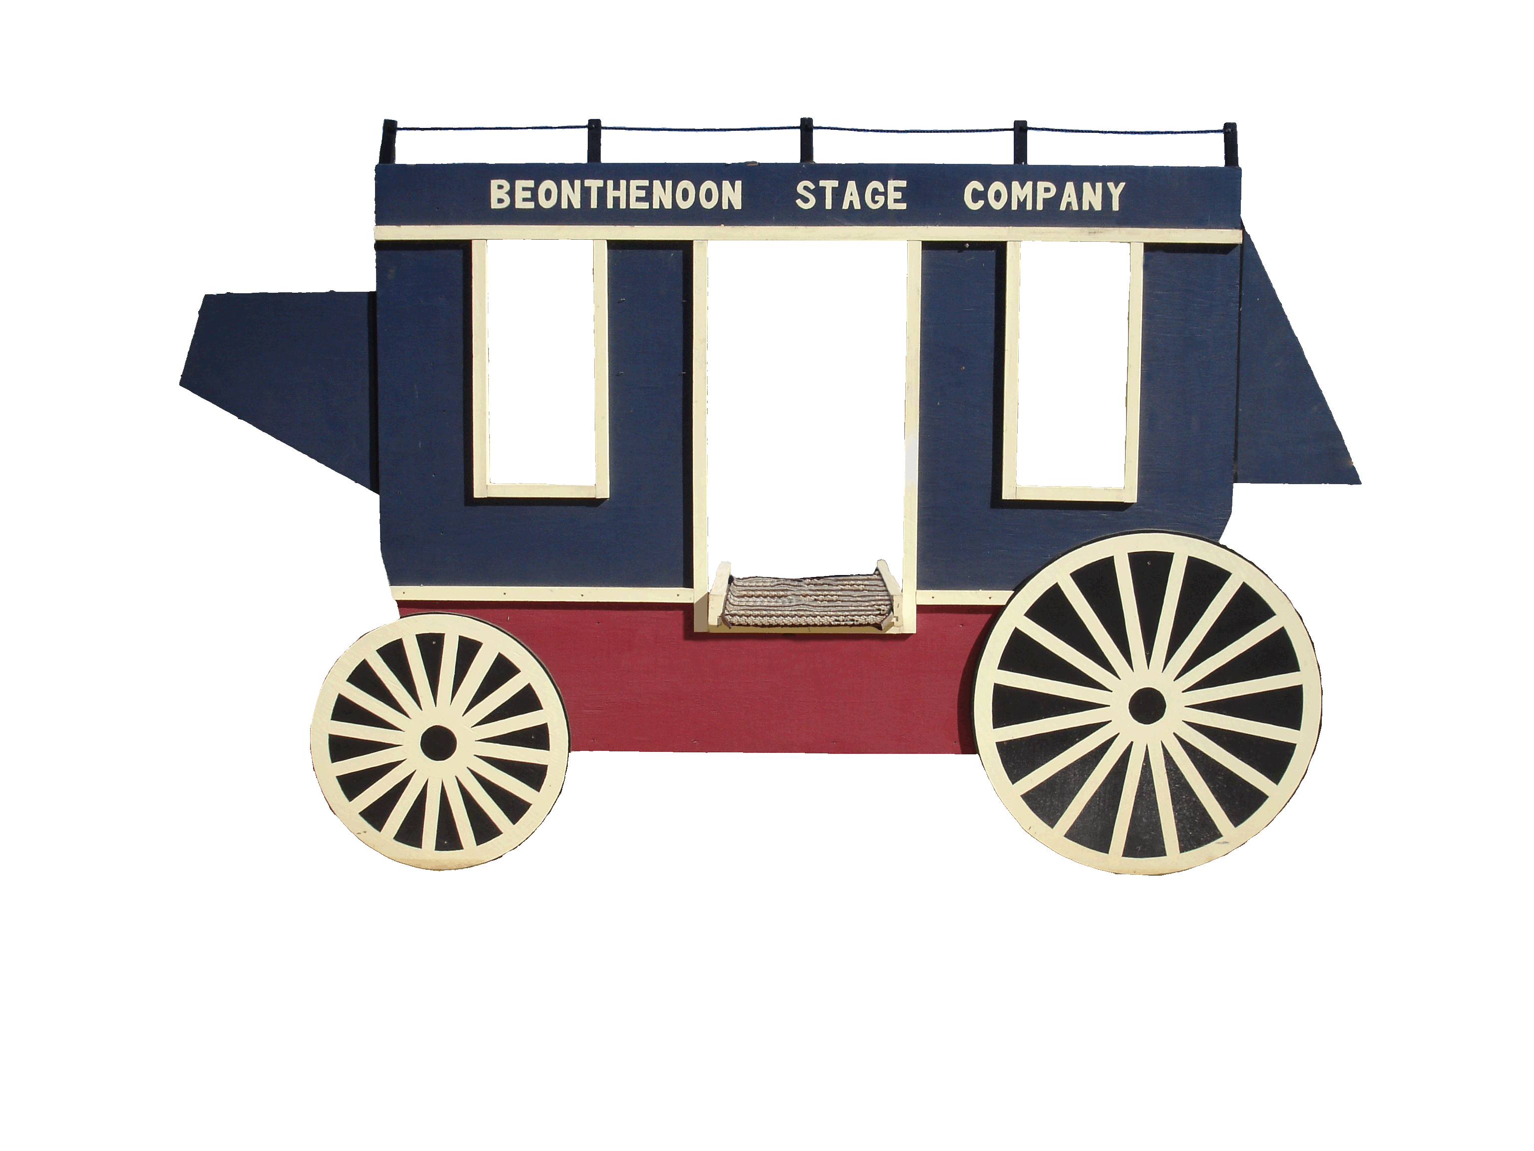
Shotgun
R2

R2

R2

24”
t
R1
R3

R3

R3

24”
t
R4
Covered Wagon
18”
m
P1

18”
m
P2

18”
m
P3

18”
m
P4

21”
t
T1
21”
t
T2
21”
t
T3
21”
t
T4
S1

S2

S3

S4

X1

Position 1
Position 2
Position 3
Rifle & Pistols

STAGE TWO (Bay #1) – “Gunfight on the trail to Mattaponi”

Sponsored By: Manakin Masonry – Major B.S. Walker

Story: The wagon team drivers, Regret Scovefield and Mad Dog Savage, have a well-deserved reputation of always making it through and delivering the goods. As they are riding along the trail to Mattaponi one day, they notice a group of riders that are bearing down on them, figuring that they are bandits Regret and Mad Dog both pull their coach guns. The bandits are Bad Rock and his evil Omaha Gang, they yell out “If you leave the wagons and run for the hills, we might let you live”. Regret Scovefield and Mad Dog Savage are hungry for a fight and yell out to their team, “Circle the wagons!!”.

Round Count: 10 pistol, 10 rifle, 2+ shotgun

Shooting Order: Pistol, Rifle, Shotgun

Staging: Rifle is loaded with 10 rounds and staged at Position 1. Both pistols are loaded with 5 rounds each and holstered. Shotgun is staged at Position 1.

Procedure: Shooter starts at Position 3 with hands on pistol(s) and when ready says “Circle the wagons!!”. At the beep with pistols engage the four pistol targets (P1, P2, P3, P4) in a Nevada Sweep, for example (P1, P2, P3, P4, P3, P2, P1, P2, P3, P4). Move to Position 1. Next with rifle engage the four rifle targets (R1, R2, R3, R4) using the same instructions as the pistols. Last with shotgun engage the (X1) knockdown target, the soda can bonus target and any remaining knockdown targets, in any order.

Notes: Misses do not count on the knockdown targets. Hitting the soda can in the air is a 5 second bonus, misses do not count on the soda can but it must be engaged. If a knockdown target is unavailable shoot where it was, maintain sequence.

STAGE TWO (Bay #1) – “Gunfight on the trail to Mattaponi”

Sponsored By: Manakin Masonry – Major B.S. Walker

Rifle & Shotgun
R2

R2

R2

24”
t
R1
R3

R3

R3

24”
t
R4
Covered Wagon
18”
m
P1

18”
m
P2

18”
m
P3

18”
m
P4

21”
t
T1
21”
t
T2
21”
t
T3
21”
t
T4
S1

S2

S3

S4

X1

Position 1
Position 2
Position 3
Pistols

STAGE THREE (Bay #2) – “Gunfight at the Bucket of Blood”

Sponsored By: Missouri Marshal’s Loadin Blocks

Story: It is a typical night at the Bucket of Blood Saloon, Pony Racer is playing the piano, Cardinal Wind and Mocking Jay are standing at the bar sipping sarsaparilla and Sod Buster is dealing faro. When in through the swinging doors walks Bad Rock and his Evil Omaha Gang. Cardinal Wind and Mocking Jay quickly decide they want to collect the bounty that is out on Bad Rock’s head, so they draw their six shooters and proclaim to Bad Rock, “We are taking you dead or alive!!”.

Round Count: 10 pistol, 10 rifle, 4(?)+ shotgun

Shooting Order: Shotgun, Pistol, Rifle, Shotgun, Shotgun

Staging: Rifle is loaded with 10 rounds and staged safely. Both pistols are loaded with 5 rounds each and holstered. Shotgun is staged safely.

Procedure: The shooter has the choice of starting at Position 1 or Position 3. The shooter starts at their starting position with the shotgun held with two hands and when ready says “We are taking you dead or alive!!”. At the beep: From Position 1 with shotgun engage the two knockdown targets (S1, S2) in any order. From Position 2 with pistols engage the five pistol targets (R1, R2, Star, R4, R5) in a West Virginia Sweep, for example (R1, R2, Plate, R4, R5, R5, R4, Plate, R2, R1). Next with rifle engage the five pistol targets (R1, R2, Star, R4, R5) using the same instructions as the pistols. Next with shotgun engage remaining plates on Star target. From Position 3 with shotgun engage the two knockdown targets (S3, S4) in any order.

Notes: Misses on the Star target do not count as misses. Any plates left on the Star at the end of Position 2 are scored as misses. If one plate knocks off other plates, it is a no call. If there are no plates available, shoot into ground and maintain sequence.

STAGE THREE (Bay #2) – “Gunfight at the Bucket of Blood”

Sponsored By: Missouri Marshal’s Loadin Blocks

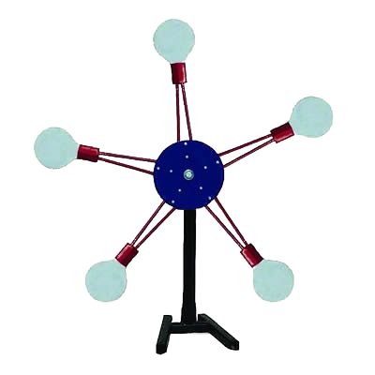
24”
t
R1
24”
t
R2
24”
t
R4
24”
t
R5
S1

S2

S3

S4

Rifle, Pistols & Shotgun
Shotgun
Tall Table
Bucket of Blood

Position 1
Position 2
Position 3
Shotgun

Barrel

Potter County Jail
Position 5
Position 4
24”
t
T3
21”
h/l
T1
21”
h/l
T2
21”
h/l
T4
21”
h/l
T5
24”
t
T6
K1

K2

K3

K4

Hay Bale
Position 6

STAGE FOUR (Bay #2) – “Gunfight in the Potter County Jail”

Sponsored By: Six Rivers Armory

Story: Cardinal Wind and Mocking Jay have just dropped off Bad Rock and his Evil Omaha Gang at the Potter County Jail and collected their bounty. The sheriff, Reb Roberts and his deputies Nevada Narrow Gauge and Enid City Kid are in the process of placing leg irons on Bad Rock when he manages to draw a pistol from one of the deputies and before you can say “Holly Crap!!” there is a gunfight going on inside of the Potter County Jail.

Round Count: 10 pistol, 10 rifle, 1+ shotgun

Shooting Order: Shotgun, Rifle, Pistols

Staging: Rifle is loaded with 10 rounds and staged safely. Both pistols are loaded with 5 rounds each and holstered. Shotgun is held with both hands.

Procedure: Shooter starts at Position 4 with both hands holding the shotgun and when ready says “Holly Crap!!”. At the beep with shotgun engage the four knockdown targets (K1, K2, K3, K4) in any order with as few rounds as needed. Move to Position 5, just inside the door beside the barrel. Next with rifle engage the six rifle targets (T1, T2, T3, T4, T5, T6) as follows: (T1, T3, T3, T5, T6, T6, T4, T3, T3, T2). Move to Position 6. Last with pistols engage the six pistol targets (T1, T2, T3, T4, T5, T6) using the same instructions as the rifle.

Notes:

STAGE FOUR (Bay #2) – “Gunfight in the Potter County Jail”

Sponsored By: Six Rivers Armory

24”
t
R1
24”
t
R2
24”
t
R4
24”
t
R5
S1

S2

S3

S4

Tall Table
Bucket of Blood

Position 1
Position 2
Position 3
Shotgun

Barrel

Potter County Jail
Position 5
Position 4
24”
t
T3
21”
h/l
T1
21”
h/l
T2
21”
h/l
T4
21”
h/l
T5
24”
t
T6
K1

K2

K3

K4

Hay Bale
Position 6

Pistols
Rifle

STAGE FIVE (Bay #3) – “Gunfight from the Outhouse”

Sponsored By: Sodan Armament

Story: Old man Goosefoot has been visiting the local Cantina and enjoying a plate of One Eyed Rooster’s beans. When he suddenly develops the urge to visit the outhouse out back. As he is sitting on the throne, he spots Bad Rock and his Evil Omaha Gang sneaking up to rob the Cantina. Putting down the corn cobs, Goosefoot picks up his guns and yells “Hands up you dirt bags!!”.

Round Count: 10 pistol, 10 rifle, 4+ shotgun

Shooting Order: Shooters Choice

Staging: Rifle is loaded with 10 rounds and staged at Position 1. Pistol are loaded with 5 rounds and staged at Position 1. Shotgun is staged at Position 1.

Procedure: Shooter has choice of shooting order but the rifle cannot be last. Shooter starts sitting in the outhouse at Position 1 holding a corn cob in both hands and when ready says “Hands up you dirt bags!!”. At the beep: With rifle engage the three rifle targets (R1, R2, R3) in the following order (R1, R2, R3, R2, R2, R1, R2, R2, R2, R3). With pistols engage the three pistol targets (P1, P2, P3) using the same instructions as the rifle. With shotgun engage the four knockdown targets (S1, S2, S3, S4) in any order.

Notes: Shooter will remain seated for the entire stage. Pistols will be staged before the shooter sits down and holstered after the shooter stands up after the stage is done.

STAGE FIVE (Bay #3) – “Gunfight from the Outhouse”

Sponsored By: Sodan Armament
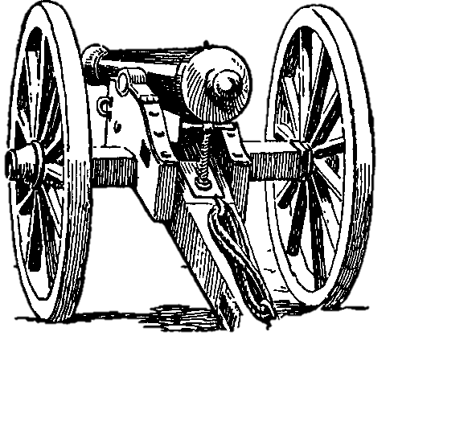
24”
t
R1
24”
t
R2
24”
t
R3
18”
m
P1
18”
m
P2
18”
m
P3
S1

S2

S3

S4

Outhouse
Position 1
Position 2
Position 3
D1
“BFI”
21”
m
C1
21”
m
C2
16”
s
A1
16”
s
A6
A2

A3

A4

A5

21”
m
B1
21”
m
B2
Rifle, Pistols & Shotgun

STAGE SIX (Bay #3) – “Gunfight at Fort Striker”

Sponsored By: Old Hickory Gun Club & Trapper Dan Trading

Story: It is half past midnight and Doc Argyle and Doc Keep’um are on guard duty on the wall of Fort Striker. They are supposed to be keeping a watchful eye but instead are huddled behind the wall rolling dice and gambling away their last nickels. As Doc Argyle is about to roll the dice again, a cannon fires a volley into the night sky, it is Bad Rock and his Evil Omaha Gang attacking the fort. Both Doc’s drop their dice, pickup their guns and join the fight.

Round Count: 10 pistol, 10 rifle, 4+ shotgun

Shooting Order: Shooters Choice

Staging: Rifle is loaded with 10 rounds and staged at Position 3. Both pistols are loaded with 5 rounds each and holstered. Shotgun is staged at Position 3.

Procedure: Shooter has choice of shooting order but the rifle cannot be last. Shooter starts at Position 2 and when ready fires the cannon. At the beep, shooter moves to Position 3. With rifle, pistols and shotgun for 24 rounds engage all targets as follows: The targets in Row A get 1 round each. The targets in Row B get 2 rounds each. The targets in Row C get 3 rounds each. The target in Row D gets eight rounds. In any order, with any gun.

Notes: Missed knockdowns may be reengaged with reloads at any time.

STAGE SIX (Bay #3) – “Gunfight at Fort Striker”

Sponsored By: Old Hickory Gun Club & Trapper Dan Trading

24”
t
R1
24”
t
R2
24”
t
R3
18”
m
P1
18”
m
P2
18”
m
P3
S1

S2

S3

S4

Outhouse
Position 1
Position 2
Position 3
D1
“BFI”
21”
m
C1
21”
m
C2
16”
s
A1
16”
s
A6
A2

A3

A4

A5

21”
m
B1
21”
m
B2
Rifle, Pistols & Shotgun

Start
Personal Score Sheet

Alias:____________________________________________________

Stage | Raw Time | Miss | Penalty | Bonus | Total
Stage 1
Stage 2
Stage 3
Stage 4
Stage 5
Stage 6
Totals

Have Fun!!
Yee-Haa!!

