The
Mattaponi Sundowners
- Presents –

Gathering

On The Mattaponi
IX
2016

Cowboys & Cowgirls,

Welcome to our ninth annual Gathering on the Mattaponi, our two day Club Championship match at the West Point Gun Club.

On Saturday we will be shooting six stages, followed by a lunch of hamburger, hot dogs and all the fixings and then finish off the day with our Side Match Competitions. The gates will open and registration will start at 8:00 am, the mandatory safety meeting will be at 9:30 am and the match itself will start at 10:00 am.

On Sunday we will shoot another six stages, then clean up the range and finish the weekend off with our Awards Ceremony. On Sunday the gates will open and registration starts at 10:00 am, the mandatory safety meeting will be at 12:00 Noon and the shooting starts at 12:30 pm.

We hope you enjoy our annual championship match and use it to start the cowboy shooting season off on a good foot. If you have any ideas or suggestions for our match, please let myself or one of the other match officials know, we are always looking to make our match better.

Thank You, Shoot Straight, Have Fun and Be Safe !!!!!!

Striker

aka Les Lillge
Match Director
Mattaponi Sundowners Chief
West Point Gun Club President

"Rio Bravo"

Stages Written by: Striker

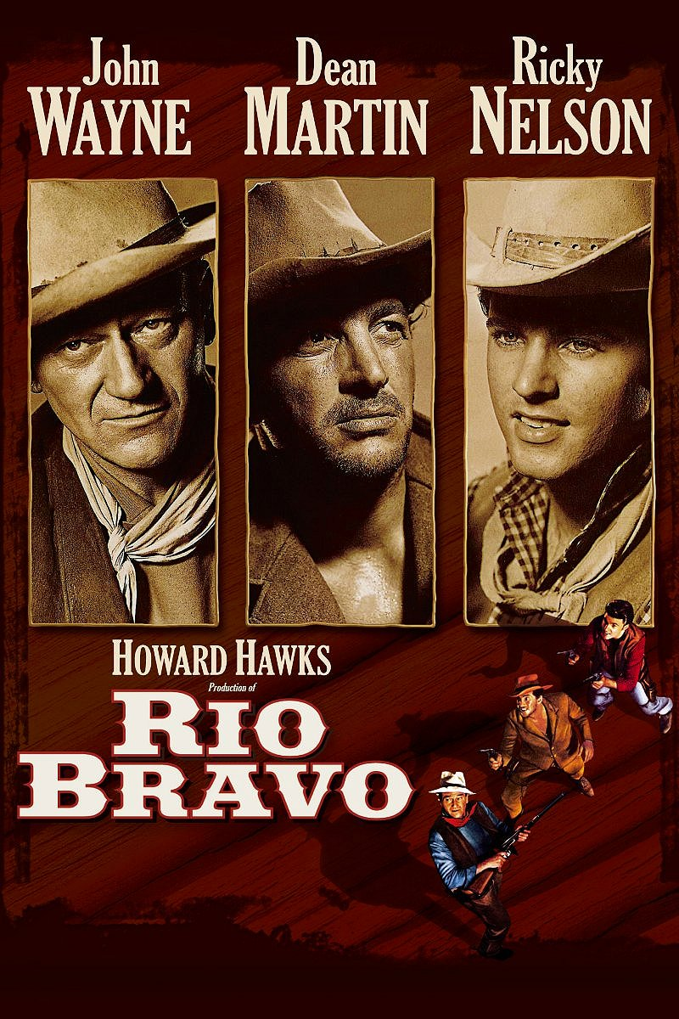
Rio Bravo is a 1959 American Western film produced and directed by Howard Hawks and starring John Wayne, Dean Martin, Ricky Nelson, Angie Dickinson, Walter Brennan, and Ward Bond. Written by Jules Furthman and Leigh Brackett, based on the short story "Rio Bravo" by B. H. McCampbell, the film is about the sheriff of the town of Rio Bravo, Texas who arrests the brother of a powerful local rancher in order to help his drunken deputy/friend. With the help of a cripple and a young gunfighter, they hold off the rancher's gang. Rio Bravo was filmed on location at Old Tucson Studios outside Tucson, Arizona in Technicolor.

In 2014, Rio Bravo was deemed "culturally, historically, or aesthetically significant" by the Library of Congress and selected for preservation in the National Film Registry.

In the town of Rio Bravo, Texas, sheriff's deputy Dude (Dean Martin), who has acquired the contemptuous nickname Borrachón (pronounced: [bo.raˈtʃon], Spanish for "drunk"), enters a saloon but can't afford a drink. Joe Burdette (Claude Akins), brother of rancher Nathan Burdette, tosses a silver dollar into a spittoon. Presidio County, Texas Sheriff John T. Chance (John Wayne) appears and kicks the spittoon away, looking at Dude with disgust. Dude is shamed by his plight and takes out his anger on Chance, knocking him out with an ax handle. Joe begins punching Dude, then shoots and kills an unarmed bystander who tries to intervene.

Joe heads to his brother's saloon, where a bloody Chance comes to arrest him for the murder of the bystander. Another patron draws his gun on Chance, but Dude shoots the gun out of the man's hand. Joe is locked up in the local jail. Chance is willing to deputize Dude, provided he can stay sober. Both remember how good with a gun Dude used to be.

Chance's friend Pat Wheeler (Ward Bond) and his wagon train of supplies stop in town, with a young gunslinger, Colorado Ryan (Ricky Nelson), riding guard. Inside the jail, Stumpy (Walter Brennan), Chance's game-legged deputy, keeps watch over the jail and Joe, who knows that Stumpy holds an old grudge against Joe's wealthy and powerful brother. Joe warns his jailers that Nathan Burdette won't like how his brother's being treated.

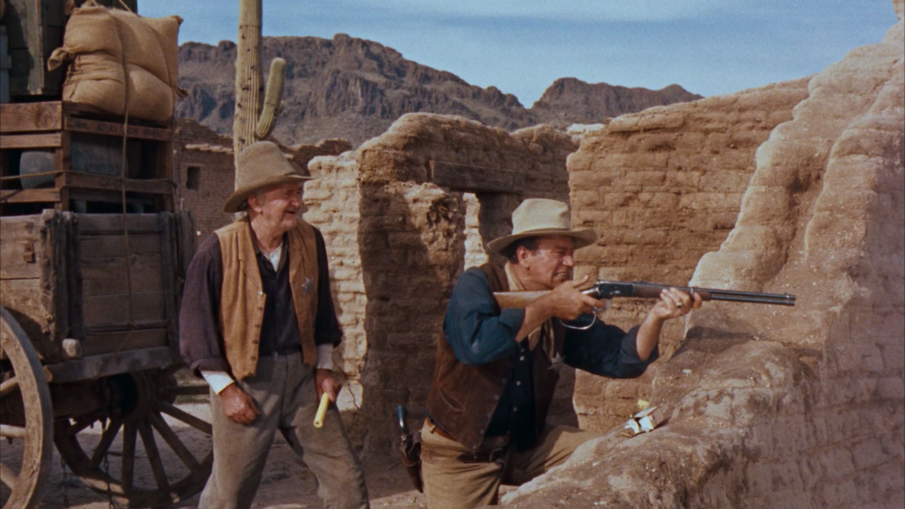
A mysterious woman nicknamed Feathers (Angie Dickinson) is in the saloon, playing poker. In the meantime, Dude and Chance patrol the town. Hotel owner Carlos (Pedro Gonzalez-Gonzalez) stops the sheriff, saying Wheeler has been talking too much about Chance needing help. In the saloon, Chance implores Wheeler to stop, as it will draw attention from the wrong people. Wheeler suggests that Colorado could be of assistance, but Colorado politely declines, saying he wants to "mind my own business." Colorado also promises not to start any trouble without telling the sheriff first.

Feathers leaves the poker game a winner. Chance follows her up to her room and confronts her as a card cheat, with his evidence three missing aces from the deck of cards being used in the game and a handbill indicating she is wanted for card cheating. Colorado intervenes, saying another participant in the game is the real cheat. They confront the card cheat and prove his guilt. Chance refuses to apologize to Feathers for doing his job, but is no longer in a hurry to make her leave town.

As Wheeler is walking back to the hotel, he is shot dead by a Burdette man hiding in the stable. Colorado offers to help but is angrily turned away by Chance, who says, "You had a chance to get in this and you didn't want it." Chance and Dude flush out the shooter, who escapes into Nathan's saloon after Dude wounds him. Dude believes the man has muddy boots, but everyone in the bar has clean boots. Two patrons suggest Dude needs a drink and one throws a silver dollar into a spittoon. The bartender puts a beer on the bar, but Dude notices blood dripping into the glass from above. He turns, fires and kills the shooter.
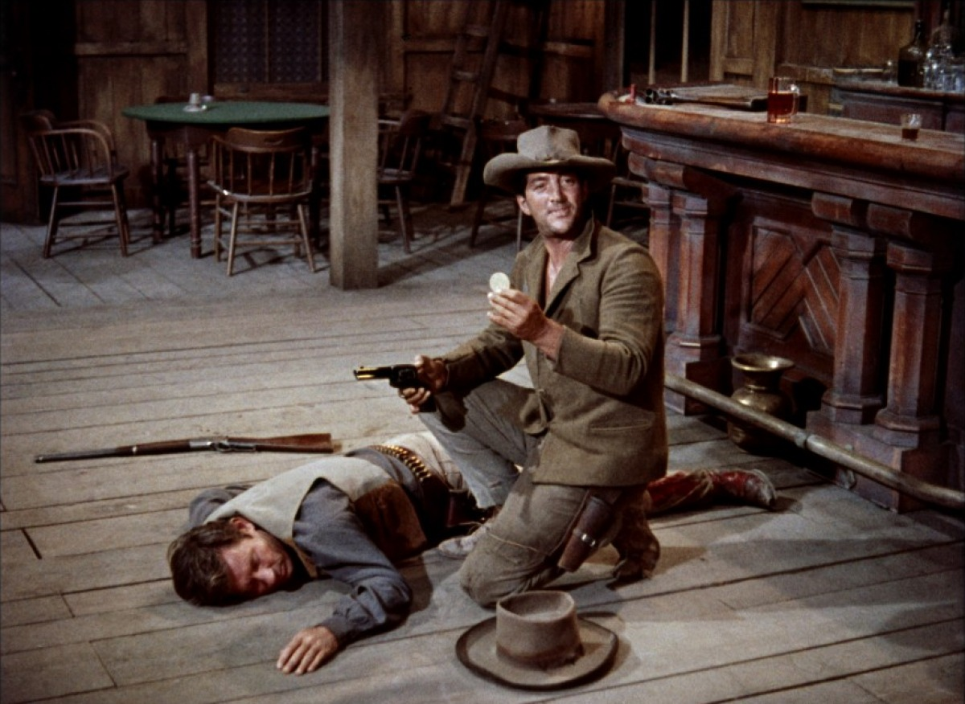

Chance goes back to the hotel to sleep. Without his knowledge, Feathers stands guard at the door to keep him safe, then returns to her room when he awakens. Chance discovers what she did and advises that she should leave on the next stagecoach.

Nathan Burdette (John Russell) arrives in town with his men, intent on seeing his brother Joe. Dude is standing guard and confiscating all guns. One of Burdette's men ignores him until Dude cuts one of his horse's reins with a single shot. Nathan agrees to turn in their guns until they leave.

Carlos says Feathers will not get on the stagecoach. She tells the sheriff she does not want to leave, then gives him a kiss. He indicates if he were not in such a fix at the jail, things between them might be different.

Colorado visits the jail to tell Chance that the meaning of a song, Degüello, or The Cutthroat Song, that Nathan is paying men to play at his saloon. The song, reported to have been played by Antonio López de Santa Anna's men at the siege of the Alamo, indicates that "no quarter" will be given to one's enemy, no mercy. Dude is trying hard to stay sober. He is given back his guns (the ones he had before he left town, sold by Dude but bought back by Chance) as well as some clothes he left behind.

The next morning, while Dude is standing guard at the town entryway, four Burdette men attack him from behind and tie him up in a stable. Others get the drop on Chance, whose rifle is just out of reach. From inside the hotel, acting on Colorado's instructions, Feathers throws a flower pot through a window a moment after Colorado steps out on the porch, distracting the Burdette men. Colorado quickly throws Chance's rifle to him and the two men shoot the three Burdette hands.
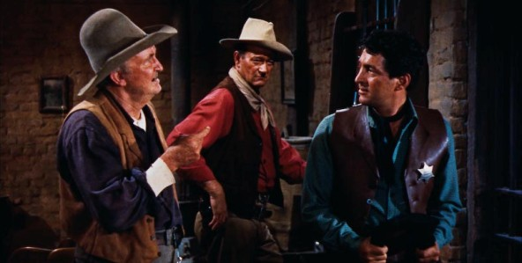

Chance decides to have his men hole up in the jail, as it will take several more days for the United States Marshal to arrive to take Joe to the Presidio. Dude's nerves are shot, but as he's about to take a drink, the sound of The Cutthroat Song played by Burdette's musicians steels his resolve. He and Chance go to the hotel to round up additional supplies, but Carlos and Consuela are captured by Burdette's men, who trick Chance into charging and falling over a rope tied at the bottom of the stairs. Dude and Feathers are unable to help.

Chance is ordered to take the men to the jail to let Joe go. He is reluctant to do so, but Dude implores Chance to cooperate, saying that Stumpy is alone and has no food or water to hold out very long. The remaining Burdette men at the hotel take Dude hostage and Nathan Burdette offers to trade him later for Joe.

Stumpy opens fire at the jail, holding off Burdette's men. Chance and Colorado then take Joe to make the trade for Dude at a warehouse, leaving Stumpy behind because of his bad leg. During the trade, walking in opposite directions, Dude tackles Joe and they scuffle while a gunfight erupts. Stumpy turns up and helps even the odds. Dude overpowers Joe. The lawmen throw dynamite sticks at the warehouse where Burdette and his men are based, shooting the sticks to explode them. After a few explosions rock the warehouse, the criminals surrender.

All is quiet in town as Chance gets reacquainted with Feathers, who models a skimpy new costume she will be wearing in her new job singing at the hotel. After the costume comes floating from a window to the street, a delighted Stumpy retrieves it, but Dude cautions him to mind his own business.

Match Sponsors

Main Match Sponsor

AA Construction Company
“Wistful McClintock & Inita Shoot”

Mattaponi Sundowners – Rules and Stage Conventions
- Revised 04-24-2013 -

- SASS Rules: All SASS Rules are in affect; unless documented here, address during the Shooter Safety Meeting or specifically stated in the stage description for a given stage.

- Round Over Berm: A round fired over the berm is a Match DQ, excluding shotguns.

- “No Alibi”: All matches at Mattaponi are “no alibi” matches. “Once the first round goes down range, the competitor is committed to the stage and must finish the stage to the best of his or her ability. Reshoots/restarts are not awarded for ammunition or firearm malfunctions. However, if there is a range failure (failure of props, timer, or the range officers) beyond the competitor’s control, a restart may be granted. On a reshoot/restart, the competitor starts over clean, carrying only accrued safety penalties forward. Restarts shall be allowed for a competitor to achieve a “clean” start up to the point at which the first round goes down range. Multiple restarts by the same shooter, that in the judgment of the R.O. are seen to be taking advantage, will not be entertained as they are not in the spirit of the game.”

- SASS Stage Conventions: Unless specifically stated in the stage description for a given stage, all SASS Stage Conventions are in affect.

- Shotgun Knockdown Misses: Unless specifically stated in the stage description for a given stage and pursuant to SASS rules, all shotgun knockdown targets may be reengaged until down, aka “Comstock Rule”.

- Loading on the Move: Loading on the move is permitted pursuant to SASS rules.

- Drawing on the Move: Drawing on the move is permitted pursuant to SASS rules.

- Muzzle Position: When there is a risk of a prop blocking the muzzle of a firearm, the muzzle must be positioned downrange of the prop, as determined by the Range Officer. For example: shooting through the window of a store front or shooting beside a wall.

- End of Stage: Unless otherwise directed by a Range Officer, after a stage has been completed the shooter will safely retrieve rifle, shotgun, and pistols and move them to the unloading table. The shooters firearms will not leave the unloading table until they have been verified “cleared” by a Range Officer.

- Coaching: Any shooter who wishes to not receive coaching must state their preference at the beginning of each stage. The Mattaponi Sundowners strongly believe that shooters helping shooters (coaching) is a critical component of the “Cowboy Way” and part of what makes this game great!! Therefore coaching is strongly encouraged and supported.

The Spotters Creed:
If you know that it’s a Hit…It’s a Hit
If you know that it’s a Miss…It’s a Miss
If you think it’s a Hit…It’s a Hit
If you think it’s a Miss…IT’S A HIT

Benefit of the doubt always goes to the shooter
STAGE ONE (Bay #1) SATURDAY

Round Count: 10 pistol, 10 rifle, 6+ shotgun

Shooting Order: Rifle, Shotgun, Shotgun, Shotgun, Pistols

Staging: Rifle is loaded with 10 rounds and staged on the barrel. Both pistols are loaded with 5 rounds each and holstered. Shotgun is staged on the barrel.

Procedure: Shooter starts standing beside the barrel with both hands holding the toy shotgun and when ready says “Sorry don't get it done, Dude”. At the beep with rifle engage the two rifle targets (L1, L2) in the following order (L1, L1, L2, L1, L1, L2, L2, L1, L2, L2). Next with shotgun engage the two shotgun targets (S1, S2) until broken. Move to beside the bucket and then engage the two shotgun targets (S3, S4) until broken. Move to the hay bale and then engage the two shotgun targets (S5, S6) until broken. Last with pistols engage the two pistol targets (L1, L2) using the same instructions as the rifle.

Note: Each pair of shotgun targets may be engaged in any order and makeups must be made before advancing to the next shooting position.
Buck Board
Wagon
24”
t
R1
24”
t
R2
24”
t
R3
24”
t
R4
S4

18”
m
P1

18”
m
P2

18”
m
P3

18”
m
P4

S2

S1

S3

Barrel
S2
S1
24”
t
L1
24”
t
L2
S3
S4
Hay Bale
S5
S6
Bucket
Rifle & Shotgun
Shotgun
Shotgun & Pistols

STAGE TWO (Bay #1) SATURDAY

Round Count: 10 pistol, 10 rifle, 4+ shotgun

Shooting Order: Pistols, Rifle, Shotgun

Staging: Rifle is loaded with 10 rounds and staged on the buckboard. Both pistols are loaded with 5 rounds each and staged on the buckboard. Shotgun is staged on the buckboard.

Procedure: Shooter will be seated on the buckboard wagon for the entire stage. Shooter starts sitting on the buckboard wagon with hands not touching guns and when ready says “Sorry don't get it done, Dude”. At the beep with pistols engage the four pistol targets (P1, P2, P3, P4) in the following order (P1, P2, P2, P1, P3, P3, P1, P4, P4, P1). Next with rifle engage the four rifle targets (R1, R2, R3, R4) in the following order (R4, R3, R3, R4, R2, R2, R4, R1, R1, R4). Last with shotgun engage the four knockdown targets (S1, S2, S3, S4) in any order.

Note: Shooter must stage pistols before sitting down, must restage pistols on wagon and after stage must standup before holstering.
Buck Board
Wagon
24”
t
R1
24”
t
R2
24”
t
R3
24”
t
R4
S4

18”
m
P1

18”
m
P2

18”
m
P3

18”
m
P4

S2

S1

S3

Barrel
S2
S1
24”
t
L1
24”
t
L2
S3
S4
Hay Bale
S5
S6
Bucket
Pistols, Rifle & Shotgun

STAGE THREE (Bay #2) SATURDAY

Round Count: 10 pistol, 10 rifle, 4+ shotgun

Shooting Order: Rifle, Shotgun, Pistols

Staging: Rifle is loaded with 10 rounds and held pointed down range. Both pistols are loaded with 5 rounds each and holstered. Shotgun is staged on the left hay bale.

Procedure: Shooter starts sitting in the outhouse with the rifle pointed down range and when ready says “I can practical' guarantee that!”. At the beep with rifle engage the five rifle targets (R1, R2, R3, R4, R5) in a West Virginia sweep, for example (R1, R2, R3, R4, R5, R5, R4, R3, R2, R1). Taking the rifle with you move to the left hay bale. Next with shotgun engage the four knockdown targets (S1, S2, S3, S4) in any order. Move to the right hay bale. Last with pistols engage the five pistol targets (R1, R2, R3, R4, R5) using the same instructions as the rifle.

Note: Shooter may standup any time after the beep.

Shotgun
Pistols
24”
t
R1
24”
m
R2
24”
t
R3
24”
m
R4
24”
t
R5
Bank of Mattaponi

S1

S2

S3

S4

Outhouse
Hay Bale
21”
s
P1
21”
s
P2
21”
s
P3
21”
s
P4
21”
s
P5
Hay Bale
S6

S8

S5

S7

Rifle

STAGE FOUR (Bay #2) SATURDAY

Round Count: 10 pistol, 10 rifle, 4+ shotgun

Shooting Order: Shotgun, Rifle, Pistols or Pistols, Rifle, Shotgun

Staging: Rifle is loaded with 10 rounds and staged in the left bank window. Both pistols are loaded with 5 rounds each and holstered. Shotgun is staged in the outhouse.

Procedure: Shooter has the choice of starting at the outhouse or right bank window. Shooter starts with hands on shooters head/hat and when ready says “I can practical' guarantee that!”. At the beep: With shotgun from the outhouse engage the four knockdown targets (S5, S6, S7, S8) in any order. With rifle from the left bank window engage the five rifle targets (R1, R2, R3, R4, R5) in the following order (middle, inside, other inside, outside, other outside, other outside, other outside, inside, other inside, middle). With pistols from the right bank window engage the five pistol targets (P1, P2, P3, P4, P5) using the same instructions as the rifle.

Note: No double taps and short cuts are allowed
24”
t
R1
24”
m
R2
24”
t
R3
24”
m
R4
24”
t
R5
Bank of Mattaponi

S1

S2

S3

S4

Outhouse
Hay Bale
21”
s
P1
21”
s
P2
21”
s
P3
21”
s
P4
21”
s
P5
Hay Bale
S6

S8

S5

S7

Pistols
Rifle
Shotgun

STAGE FIVE (Bay #3) SATURDAY

Round Count: 10 pistol, 10 rifle, 8+ shotgun

Shooting Order: Rifle, Pistols, Shotgun, Shotgun or Shotgun, Shotgun, Rifle, Pistols

Staging: Rifle is loaded with 10 rounds and staged at the right position. Both pistols are loaded with 5 rounds each and holstered. Shotgun is staged safely. Fort Window in the Down Position.

Procedure: Shooter has choice of starting at either the right or left position. Shooter starts standing at their start position and when ready says “How do ya like them apples?”. At the beep: From the right position with the rifle engage the three rifle targets (V1, V2, V3) in a “Middle Progressive Sweep” for example (V1, V2, V3, V2, V2, V1, V2, V2, V2, V3). Next with pistols engage the three pistol targets (T1, T2, T3) using the same instructions as the rifle. From the middle position with shotgun engage the four knockdown targets (S5, S6, S7, S8) in any order. From the left position with shotgun engage the four knockdown targets (S1, S2, S3, S4) in any order.

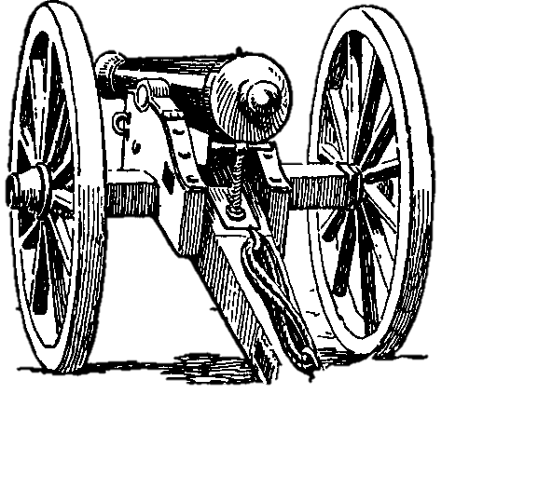
Shotgun
Tall Table
R3
“BFI”
21”
h/l
R1
21”
h/l
R2
21”
h/l
R4
21”
h/l
R5
21”
h/l
P1
21”
h/l
P2
21”
h/l
P4
21”
h/l
P5
21”
h/l
P3
S1

S2

S3

S4

S5

S6

S7

S8

18”
h/l
T1

18”
h/l
T2

18”
h/l
T3

24”
t
V1
24”
t
V2
24”
t
V3
Shotgun
Rifle & Pistols

STAGE SIX (Bay #3) SATURDAY

Round Count: 10 pistol, 10 rifle, 4+ shotgun

Shooting Order: Pistols, Shotgun, Rifle, Shotgun or Rifle Shotgun, Pistols, Shotgun

Staging: Rifle is loaded with 10 rounds and staged at the middle position. Both pistols are loaded with 5 rounds each and holstered. Shotgun is staged safely. Fort Window in the Down Position.

Procedure: Shooter has the choice of starting at either the left or middle positions. Shooter starts standing at their start position with hands on fort wall and when ready says “How do ya like them apples?”. At the beep: From the left position with pistols engage the five pistol targets (P1, P2, P3, P4, P5) with single taps on the outside targets, double taps on the middle target and all targets engaged, for example (P1, P3, P3, P2, P3, P3, P4, P3, P3, P5). Next with shotgun engage two of the four knockdown targets (S1, S2, S3, S4) in any order. From the middle position with rifle engage the five rifle targets (R1, R2, R3, R4, R5) using the same instructions as the pistols. Next with shotgun engage two of the four knockdown targets (S5, S6, S7, S8) in any order.

Tall Table
R3
“BFI”
21”
h/l
R1
21”
h/l
R2
21”
h/l
R4
21”
h/l
R5
21”
h/l
P1
21”
h/l
P2
21”
h/l
P4
21”
h/l
P5
21”
h/l
P3
S1

S2

S3

S4

S5

S6

S7

S8

18”
h/l
T1

18”
h/l
T2

18”
h/l
T3

24”
t
V1
24”
t
V2
24”
t
V3
Rifle & Shotgun
Pistols & Shotgun

STAGE SEVEN (Bay #1) SUNDAY

Round Count: 10 pistol, 10 rifle, 4+ shotgun

Shooting Order: Rifle, Shotgun, Pistols

Staging: Rifle is loaded with 10 rounds and pointed down range. Both pistols are loaded with 5 rounds each and holstered. Shotgun is staged on the bar.

Procedure: Shooter starts standing at the bar with the rifle pointed down range and when ready says “Hey, sheriff, you forgot your pants”. At the beep, with rifle engage the five rifle targets (R1, R2, X3, R4, R5) in the following order (X3, R1, X3, R5, X3, R2, R2, X3, R4, R4). Next with shotgun engage the four knockdown targets (S1, S2, S3, S4) in any order. Last with pistols engage the five pistol targets (P1, P2, X3, P4, P5) using the same instructions as the rifle.

STAGE EIGHT (Bay #1) SUNDAY

Bar
24”
t
R1
24”
t
R2
24”
m
X3
24”
t
R4
24”
t
R5
18”
s
P1

18”
s
P2

18”
s
P4

18”
s
P5

S1

S2

S3

S4

L2

L2

L2

L3

L3

L3

24”
t
L1
24”
t
L4
18”
s
M1

18”
s
M2

18”
s
M3

18”
s
M4

Rifle, Pistols & Shotgun

Round Count: 10 pistol, 10+ rifle, 4+ shotgun

Shooting Order: Rifle, Pistols, Shotgun or Shotgun, Rifle, Pistols

Staging: Rifle is loaded with 10 rounds and staged in the window. Both pistols are loaded with 5 rounds each and holstered. Shotgun is staged at the middle of the bar.

Procedure: Shooter starts standing between the cacti and has a choice of going to the window or bar first. When ready shooter says “Hey, sheriff, you forgot your pants”. At the beep shooter moves to their start position: From the bar with shotgun engage the four knockdown targets (S1, S2, S3, S4) in any order. From the window with rifle engage the rifle targets (L1, L2, L3, L4) in a Nevada Sweep, for example (L1, L2, L3, L4, L3, L2, L1, L2, L3, L4). After completing sweep, shooter may reload rifle to knockdown any remaining tombstones, misses do not count on tombstones, only tombstones left standing at end of stage count as misses. Next with pistols engage the four pistol targets (M1, M2, M3, M4) in a Nevada Sweep.

Bar
24”
t
R1
24”
t
R2
24”
m
X3
24”
t
R4
24”
t
R5
18”
s
P1

18”
s
P2

18”
s
P4

18”
s
P5

S1

S2

S3

S4

L2

L2

L2

L3

L3

L3

24”
t
L1
24”
t
L4
18”
s
M1

18”
s
M2

18”
s
M3

18”
s
M4

Pistols & Rifle
Shotgun
Start

STAGE NINE (Bay #2) SUNDAY

Round Count: 10 pistol, 10 rifle, 2+ shotgun

Shooting Order: Rifle, Pistols, Shotgun

Staging: Rifle is loaded with 10 rounds and staged in outhouse. Both pistols are loaded with 5 rounds each and holstered. Shotgun is staged in outhouse.

Procedure: Shooter starts standing in the outhouse with hands above shoulders and when ready says “You want that gun, pick it up”. At the beep with rifle engage the three rifle targets (R1, R2, R3) in a 3-1-1 from one direction then a 3-1-1 from the other direction, for example (R1, R1, R1, R2, R3, R3, R3, R3, R2, R1). Next with pistols engage the three pistol targets (P1, P2, P3) using the same instructions as the rifle. Last with shotgun engage the two knockdown targets (S5, S6) in any order.

Bank of Mattaponi

Outhouse
24”
t
R1
24”
t
R3
24”
m
R2
21”
t
X1
21”
t
X2
21”
t
X4
21”
t
X3
21”
m
V1
21”
m
V2
21”
m
V4
21”
m
V3
S2

S4

S1

S3

18”
m
P1

18”
s
P2

18”
m
P3

S5

S6

Rifle, Pistols & Shotgun

STAGE TEN (Bay #2) SUNDAY

Round Count: 10 pistol, 8 rifle, 4+ shotgun

Shooting Order: Shotgun, Rifle, Pistols or Rifle, Pistols, Shotgun

Staging: Rifle is loaded with 8 rounds and staged in the right window. Both pistols are loaded with 5 rounds each and holstered. Shotgun is staged in the stage coach.

Procedure: Shooter starts standing in the outhouse and has the choice of going to the right window or stage coach first. When ready shooter says “You want that gun, pick it up”. At the beep shooter moves to their starting position: From the stage coach with shotgun engage the four knockdown targets (S1, S2, S3, S4) in any order. From the right window with rifle engage the eight rifle targets (X1, X2, X3, X4, V1, V2, V3, V4) each with a single tap. Next with pistols engage the four pistol targets (V1, V2, V3, V4) with double taps, all targets engaged.

STAGE ELEVEN (Bay #3) SUNDAY
Bank of Mattaponi

Outhouse
24”
t
R1
24”
t
R3
24”
m
R2
21”
t
X1
21”
t
X2
21”
t
X4
21”
t
X3
21”
m
V1
21”
m
V2
21”
m
V4
21”
m
V3
S2

S4

S1

S3

18”
m
P1

18”
s
P2

18”
m
P3

S5

S6

Shotgun
Rifle & Pistols
Start

Round Count: 10 pistol, 10 rifle, 4+ shotgun

Shooting Order: Pistols, Rifle, Shotgun

Staging: Rifle is loaded with 10 rounds and staged at the left fort. Both pistols are loaded with 5 rounds each and holstered. Shotgun is staged at the left fort. Fort Window in the Down Position.

Procedure: Shooter starts standing at the left fort with hands on pistol(s) and when ready says “A bum-legged old man and a drunk”. At the beep with pistols engage the four pistol targets (P1, P2, P3, P4) in a Progressive Sweep, for example (P1, P2, P2, P3, P3, P3, P4, P4, P4, P4). Next with rifle engage the four rifle targets (R1, R2, R3, R4) using the same instructions as the pistols. Last with shotgun engage the four knockdown targets (S1, S2, S3, S4) in any order.

Shotgun, Rifle & Pistols
Tall Table
21”
h/l
R1

21”
h/l
R2

21”
h/l
R3

21”
h/l
R4

18”
h/l
P1

18”
h/l
P2

18”
h/l
P3

18”
h/l
P4

S1

S2

S3

S4

24”
m
X1
24”
t
X2
24”
m
X3
24”
m
X4
24”
t
X5
24”
m
X6
21”
s
V1
21”
s
V2
21”
s
V3
21”
s
V4
21”
s
V5
21”
s
V6
S5

S6

S7

S8

STAGE TWELEVE (Bay #3) SUNDAY

Round Count: 10 pistol, 10 rifle, 4+ shotgun

Shooting Order: Rifle, Pistols, Shotgun, or Shotgun, Rifle, Pistols

Staging: Rifle is loaded with 10 rounds and staged in the middle fort. Both pistols are loaded with 5 rounds each and holstered. Shotgun is staged in the right fort. Fort Window in the Down Position.

Procedure: Shooter starts standing between middle and right forts and has choice of going to the middle or right forts first. When ready shooter says “A bum-legged old man and a drunk”. At the beep shooter moves to their start position: From the middle fort with rifle engage the six rifle targets (X1, X2, X3, X4, X5, X6) as follows middle, other middle, inside, other inside, outside, other outside, inside, other inside, middle, other middle. Next with pistols engage the six pistol targets (V1, V2, V3, V4, V5, V6) using the same instructions as the rifle. From the right fort with shotgun engage the four knockdown targets (S5, S6, S7, S8) in any order.

Tall Table
21”
h/l
R1

21”
h/l
R2

21”
h/l
R3

21”
h/l
R4

18”
h/l
P1

18”
h/l
P2

18”
h/l
P3

18”
h/l
P4

S1

S2

S3

S4

24”
m
X1
24”
t
X2
24”
m
X3
24”
m
X4
24”
t
X5
24”
m
X6
21”
s
V1
21”
s
V2
21”
s
V3
21”
s
V4
21”
s
V5
21”
s
V6
S5

S6

S7

S8

Rifle & Pistols
Shotgun
Start

Personal Score Sheet

Alias:____________________________________________________

Stage | Raw Time | Miss | Penalty | Bonus | Total
Stage 1
Stage 2
Stage 3
Stage 4
Stage 5
Stage 6
Stage 7
Stage 8
Stage 9
Stage 10
Stage 11
Stage 12
Totals

Have Fun!!
Yee-Haa!!

