***BE KIND TO YOU HEART MONTH***

C:\Program Files\Microsoft Office\MEDIA\CAGCAT10\j0235241.wmf

**CONGESTIVE HEART FAILURE**

**Causes of CHF:**

1. Hypertension
2. Abnormal Heart Valves
3. Coronary Heart Disease
4. Cardiomyopathy
5. Severe Lung Disease
6. Congenital Heart Disease
7. Severe Anemia
8. Overactive Thyroid
9. Abnormal Heart Rhythm

**Signs and Symptoms of CHF:**

1. Sudden weight gain (2-3 lbs in 2-3 days)

Monitor weight daily; same time of day, same scales (on a hard surface), and same type of clothes.

1. Swelling of lower limbs
2. Swelling or pain in the abdomen
3. Trouble sleeping or orthopnea
4. Shortness of breath
5. Frequent, dry, hacking cough (most often when lying down)
6. Loss of appetite

**Ways to improve heart function:**

1. Lose weight
2. Don’t smoke
3. Avoid hard exercise and lifting heavy objects
4. Wear clothes that permit good blood flow in the legs.
5. Avoid temperature extremes
6. Get yearly flu vaccine and pneumonia vaccine every 5 years until age 65 and then once after 65
7. Limit caffeine
8. Don’t drink alcohol
9. Limit salt to 2,000mg per day
10. Take meds as prescribed, especially Lasix
11. Try to lightly exercise daily
12. Avoid eating fatty foods



**HEART ATTACK (MI)**

**Ways to lower risk of a MI:**

1. Quit smoking
2. Control and Monitor blood pressure
3. Reduce fat, cholesterol, and salt in diet
4. Include a daily exercise routine ( start slowly and increase slowly)
5. Lose weight and control weight
6. Reduce stress and tension

**Diet changes:**

1. 2,000mg of salt or less daily
2. Eat less red meat or marbled meat
3. Eat less fatty foods or high cholesterol foods
4. Read labels for fat and sodium content
5. Change cooking to more baked, broiled, grilled, or steamed foods

**Proper NTG (nitroglycerin) use:**

1. Keep NTG in brown bottle it comes in and at room temperature.
2. Replace the bottle before they expire, usually about 1 yr.
3. Keep NTG with you.
4. When chest pain starts; stop what you are doing and rest and if chest pain continues place 1 NTG tab under your tongue (DONOT chew or swallow), if chest pain continues you may repeat in 3-5 minutes with another (1) tab, if chest pain continues and a third NTG is needed another (1) tab and **call 911.** Max of 3 tabs in 15 minutes.
5. If NTG is not available chew a non-coated aspirin and call 911.

***Signs and Symptoms of a Heart Attack (MI)***

1. Prolonged discomfort or band of pressure
2. Aching, burning, tightness, or squeezing sensation
3. Indigestion, fullness or heaviness in chest
4. Choking feeling
5. Sweating
6. Nausea or vomiting
7. Dizziness
8. Palpations
9. Severe weakness

**If CHEST PAIN last more than 15 minutes, call 911 and DO NOT attempt to drive!**

**Stage 1: (bay 2)**

10 pistol, 10 rifle, and 4+ shotgun

Procedure: The rifle is loaded with 10 rounds with hammer down, lever closed and staged on the barrel at the left. The shotgun is open, empty and staged safely. The pistols are loaded with 5 rounds each with hammer down on empty chamber and holstered.

The shooter starts standing at the barrel with his hands hanging loosely at their side and when ready says**: “It’s a pacemaker, not a peacemaker.”** At the beep, retrieve the rifle and place 1 round on R1, 1 round on R2, 1 round on R3, 1 round on R4, 1 round on R1, 1 round on R2, 1 round on R3, 1 round on R1, 1 round on R2 and 1 round on R1. Make rifle safe. Move to the end of fence, shoot shotgun targets S3 thru S6, in any order until all are down. Make shotgun safe. Move back to barrel on the left, draw your pistols per your category and repeat the same rifle sequence with the pistols on P1-P4. Retrieve long guns and move to the unloading table.

24”

R6

t

24”

R5

t

24”

R4

t

24”

R3

t

24”

R2

t

24”

**R1**

t

18”

P4

m

18”

P3

m

18”

P2

m

18”

P1

m

18”

P6

m

18”

P5

m

S2

S1

S3

S4

S5

S6

**Barrel**

**Barrel**

**Hay Bale**

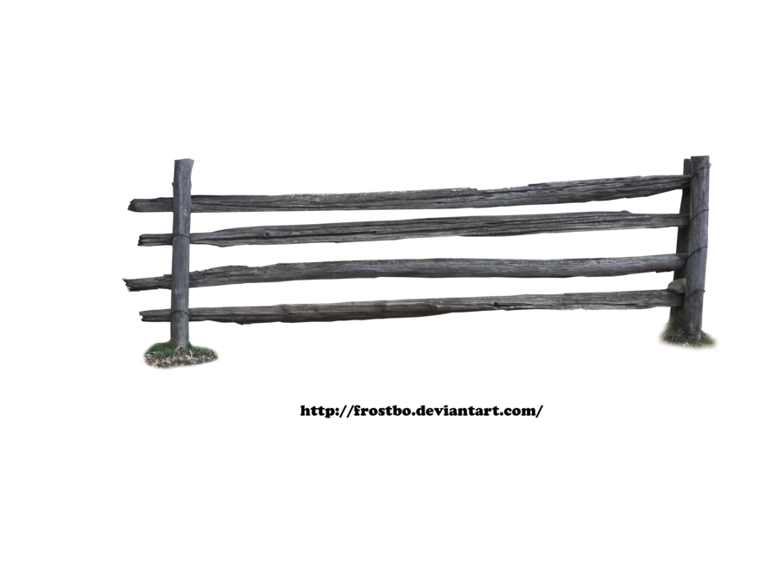

**Stage 2: (Bay 2)**

10 pistol, 10 rifle, and 4+ shotgun

Procedure: The rifle is loaded with 10 rounds with hammer down, lever closed and staged on the hay bale on right. The shotgun is open, empty and staged on the tall table at the end of fence. The pistols are loaded with 5 rounds each with hammer down on empty chamber and holstered.

The shooter starts standing at the right hay bale and with his hands hanging loosely at their side and when ready says**: “It’s a pacemaker, not a peacemaker.”** At the beep, draw pistols per your category and shoot a progressive sweep on P5 and P6 for 10 rounds, starting on either end, for example (P5, P6, P6, P5, P5, P5, P6, P6, P6, P6). Retrieve the rifle and shoot rifle targets R5 and R6 by repeating the same sequence as the pistols. Make rifle safe. Move to barrel in the center and shoot shotgun targets S3-S6, in any order until all are down. Retrieve long guns and move to the unloading table.

24”

R6

t

24”

R5

t

24”

**R4**

t

24”

**R3**

t

24”

**R2**

t

24”

**R1**

t

18”

P4

m

18”

P3

m

18”

P2

m

18”

P1

m

18”

P6

m

18”

P5

m

S2

S1

S3

S4

S5

S6

**Barrel**

**Barrel**

**Hay Bale**



**Stage 3: (bay 2)**

10 pistol, 10 rifle, and 4+ shotgun

Procedure: The rifle is loaded with 10 rounds with hammer down, lever closed and staged on the barrel at the left. The shotgun is open, empty and held at port arms. The pistols are loaded with 5 rounds each with hammer down on empty chamber and holstered.

The shooter starts standing at the barrel at the left with shotgun at port arms and when ready says**: “It’s a pacemaker, not a peacemaker.”** At the beep, with shotgun; shoot shotgun targets S1 and S2, in any order until all are down. Make shotgun safe. With rifle place 2 rounds each on R1-R4 then 1 round each on R5and R6. Make rifle safe. Draw your pistols per your category, place 2 rounds each on P1-P4 then 1 round each on P1 and P4. Holster pistols. Move with shotgun to center barrel, engage the knock down and popper, a hit on popper is a 5 second bonus, must engage popper, no penalty for a miss on popper. Retrieve long guns and move to the unloading table.

**Popper**

24”

R6

t

24”

R5

t

24”

R4

t

24”

R3

t

24”

R2

t

24”

**R1**

t

18”

P4

m

18”

P3

m

18”

P2

m

18”

P1

m

18”

P6

m

18”

P5

m

S2

S1

S3

S4

S5

S6

**Barrel**

**Barrel**

**Hay Bale**



**Stage 4: (bay 3)**

10 pistol, 10 + 1 rifle, and 4+ shotgun

Procedure: The rifle is loaded with 10 rounds with hammer down, lever closed and staged on the fort. The shotgun is open, empty and staged on the fort. The pistol are loaded with 5 rounds each with hammer down on empty chamber and holstered.

The shooter starts standing at the fort window with his hands on the shotgun and when ready says**: “Cowboys have a heart of gold.”** At the beep, with shotgun engage S1 – S4 in any order, all must fall. Make shotgun safe. Retrieve the rifle and shoot a Nevada sweep on R3 thru R1 and then R3 thru R5 (R3, R2, R1, R2, R3, R3, R4, R5, R4, R3) then reload 1 round, hit the clay for 5 seconds bonus, must shoot but no penalty for a miss. Make rifle safe. Draw your pistols per your category and repeat the same as the rifle sequence on P1-P5. Retrieve long guns and move to the unloading table.

24”

**R3**

t

24”

**R4**

t

24”

**R2**

t

24”

**R5**

t

24”

**R1**

t

Bonus

16”

R6

16”

R7

16”

R8

P1

s

P5

s

P4

s

P2

s

P3

s

S1

S2

S4

S3

P6

s

P8

s

P7

s



**Stage 5: (bay 3)**

10 pistol, 10 rifle, and 4+ shotgun

Procedure: The rifle is loaded with 10 rounds with hammer down, lever closed and held at port arms. The shotgun is open, empty and staged on the fort. The pistol are loaded with 5 rounds each with hammer down on empty chamber and holstered.

The shooter starts standing at the fort window, with rifle held at port arms and when ready says**: “Cowboys have a heart of gold.”** At the beep, with the rifle; place 1 round on R1-R5 and P1-P5 in a clockwise motion, starting on any target. Make rifle safe. Draw your pistols per your category, engage the pistol targets P1-P5 as follows; 1 on the outside target, 1 round on the other outside target, 1 round on the inside target, 1 round on the other inside target, and 1 round on the middle target and repeat the instructions (doesn’t have to be exact). Retrieve the shotgun, shoot shotgun targets S1 and S2 then S3 and S4, in that order; all must fall. Make shotgun safe. Retrieve long guns and move to the unloading table.

24”

**R3**

t

24”

**R4**

t

24”

**R2**

t

24”

**R5**

t

24”

**R1**

t

Bonus

16”

R6

16”

R7

16”

R8

P1

s

P5

s

P4

s

P2

s

P3

s

S1

S2

S4

S3

P6

s

P8

s

P7

s



**Stage 6: (bay 3)**

10 pistol, 10 rifle, and 4+ shotgun

Procedure: The rifle is loaded with 10 rounds with hammer down, lever closed and staged on the horse. The shotgun is open and empty and staged on the horse. The pistol are loaded with 5 rounds each with hammer down on empty chamber and holstered. Fort window is in the UP position.

The shooter starts standing at the horse with hands touching the horse and when ready says**: “Cowboys have a heart of gold.”** At the beep, with rifle and place 2 rounds on R6, 1 round on R7, 2 rounds on R8, 2 rounds on R6, 1 round on R7, and 2 rounds on R8, Make rifle safe. Draw your pistols per your category and repeat the same sequence as the rifle on P6-P8 targets. Holster pistols. Retrieve the shotgun; move to fort and open window, shoot shotgun targets S1 thru S 4 in any order. Make shotgun safe. Retrieve long guns and move to the unloading table.

24”

**R3**

t

24”

**R4**

t

24”

**R2**

t

24”

**R5**

t

24”

**R1**

t

Bonus

16”

R6

16”

R7

16”

R8

P1

s

P5

s

P4

s

P2

s

P3

s

S1

S2

S4

S3

P6

s

P8

s

P7

s



***KEEP YOUR HEART HEALTHY!!***

***BE KIND TO YOUR HEART***

Sunday, February 21, 2016

***Match written : Pat Graves aka Sassy Shooting Sours***

**As you all know, Doc Argyle had open heart surgery in January to replace his aortic valve. He is recovering nicely. Texas Dave, in the past year, as also had open heart surgery and has recovered. This is only 2 of our “cowboy” friends and I’m sure there are others. Heart disease affects many of us and it’s a number one killer. Let’s celebrate “Heart Health Month” with a match but also doing all we can to keep our hearts healthy.**

I wanted to say I count it a blessing when I can share my professional career with you and stories of our shooters, if it helps you, we all win. I think that I win the most because ***you*** will still be here to be my friend and competitor. I have never met a group of people like SASS cowboys and cowgirls in my life. You are people that compete with each other but at the same time you are willing to help the other person when things go bad in a match or life. This is a spirit that can only be generated from the heart and soul. If we know someone with heart disease or risk for heart disease let them know that you care and you are willing to help them with that and also lend them support.

There has been such an out pouring of your support in the past years to many. Please continue with the support, prayers, friendship and love for each other; it does matter. If you know of someone with heart conditions please share today’s match information.

Let’s come out Sunday and support each other in love, shooting and in caring of each other. COWBOYS and COWGIRLS TRULY HAVE A HEART OF GOLD!!!

**Mattaponi Sundowners**

**– Rules and Stage Conventions**

**- Revised 04-24-2013 -**

• **SASS Rules**: All SASS Rules are in affect; unless documented here, address during the Shooter Safety Meeting or specifically stated in the stage description for a given stage.

• **Round Over Berm**: A round fired over the berm is a Match DQ, excluding shotguns.

• **“No Alibi”**: All matches at Mattaponi are “no alibi” matches. *“Once the first round goes down range, the competitor is committed to the stage and must finish the stage to the best of his or her ability. Reshoots/restarts are not awarded for ammunition or firearm malfunctions. However, if there is a range failure (failure of props, timer, or the range officers) beyond the competitor’s control, a restart may be granted. On a reshoot/restart, the competitor starts over clean, carrying only accrued safety penalties forward. Restarts shall be allowed for a competitor to achieve a “clean” start up to the point at which the first round goes down range. Multiple restarts by the same shooter, that in the judgment of the R.O. are seen to be taking advantage, will not be entertained as they are not in the spirit of the game.”*

• **SASS Stage Conventions:** Unless specifically stated in the stage description for a given stage, all SASS Stage Conventions are in affect.

• **Shotgun Knockdown Misses**: Unless specifically stated in the stage description for a given stage and pursuant to SASS rules, all shotgun knockdown targets may be reengaged until down, aka “Comstock Rule”.

• **Loading on the Move**: Loading on the move is permitted pursuant to SASS rules.

• **Drawing on the Move**: Drawing on the move is permitted pursuant to SASS rules.

• **Muzzle Position**: When there is a risk of a prop blocking the muzzle of a firearm, the muzzle must be positioned downrange of the prop, as determined by the Range Officer. For example: shooting through the window of a store front or shooting beside a wall.

• **End of Stage**: Unless otherwise directed by a Range Officer, after a stage has been completed the shooter will safely retrieve rifle, shotgun, and pistols and move them to the unloading table. The shooters firearms will not leave the unloading table until they have been verified “cleared” by a Range Officer.

• **Coaching**: Any shooter who wishes to not receive coaching must state their preference at the beginning of each stage. The Mattaponi Sundowners strongly believe that shooters helping shooters (coaching) is a critical component of the “Cowboy Way” and part of what makes this game great!! Therefore coaching is strongly encouraged and supported.

**The Spotters Creed:**

If you know that it’s a Hit…It’s a Hit

If you know that it’s a Miss…It’s a Miss

If you think it’s a Hit…It’s a Hit

If you think it’s a Miss…IT’S A HIT

Benefit of the doubt always goes to the shooter